# Week 2 Progress Report

Misato Morino, Bo Pang, Min Song, Zhihao Xue

# Status

**Completed Tasks:**

Week 1

* Implemented HSV color range for bright and shaded green.
* Masked Image by extracting green.
* Used morphology to clear up the image.
* Tested Tesseract over mask

Week 2

We have modified and implemented a better algorithm to detect and extract the traffic sign so that Tesseract does a better job recognizing the texts.

* Improved HSV color range
* Implemented canny edge detection to detect the traffic sign
* Implemented cropping the traffic sign
* Implemented perspective correction (rotation) of the cropped image based on the corners detected by edge detection.
* Improved our mask generator.
* Tested over larger set of images.
* Re-organized our code so it is easier to debug and read.

**Incomplete Tasks:**

We will need to organize and pre-process our test set to classify successes and failures.

# Plan

|  |  |  |
| --- | --- | --- |
| Goals | Target Date | Status |
| Setting up and learning OpenCV and Tesseract | Jan 31 | Done |
| Find, create traffic sign data set | Feb 5 | Done |
| Detecting field using HSV | Feb 5 | Done |
| Detect traffic signs | Feb 5 | Done |
| Extract texts from the traffic sign | Feb 5 | Done |
| Run Tesseract over the extracted text | Feb 12 | Done |
| Run our algorithm over large test set and modify failed images | Feb 12 | Incomplete |
| Organize results | Feb 15 | Incomplete |
| Stretch Goals | Feb 19 | Incomplete |

# Achievements Example: DSC_0634.JPG perspective correction

Input Image:

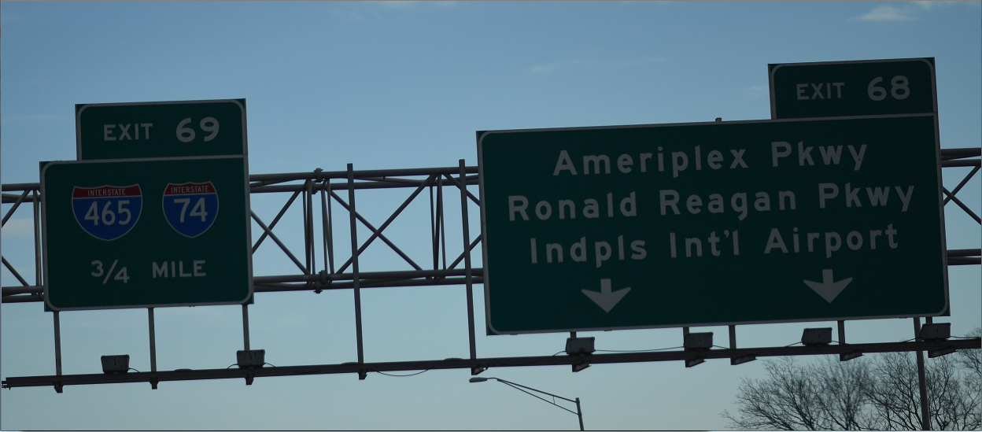

New customized mask: (HSV + RGB to cover traffic signs with shadows detection)

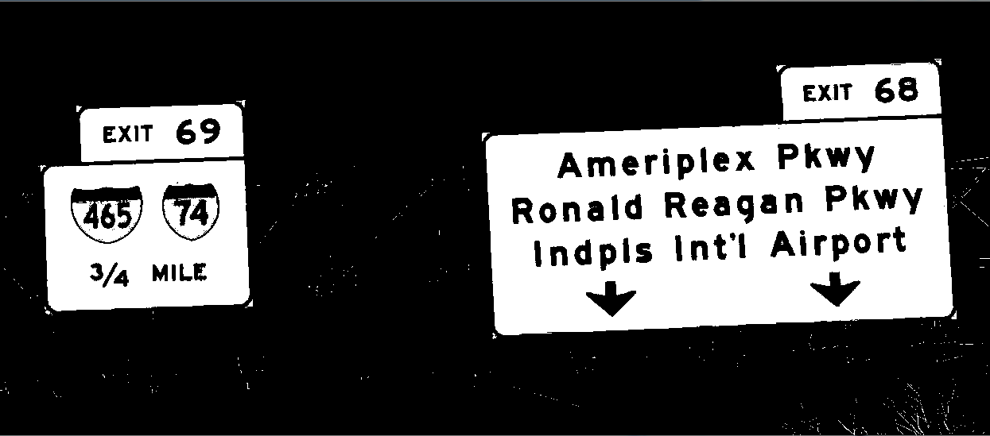

Perspective Correction on the new mask:

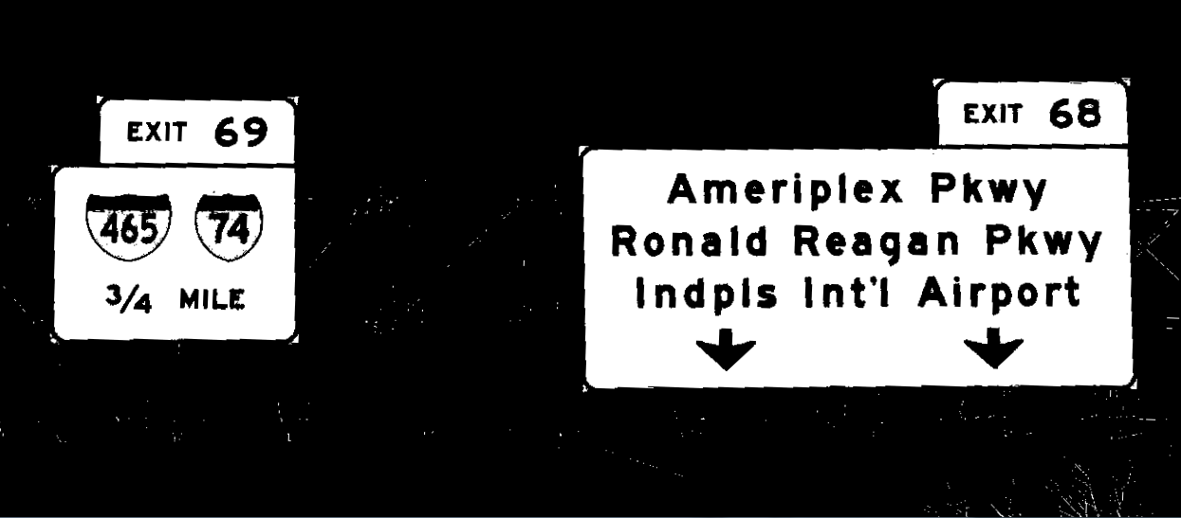

Tesseract Output:

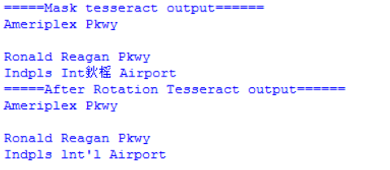

# Achievement Example: traffic3.JPG: Edge detection and auto crop

Original image w/ contour: Canny edge detection:

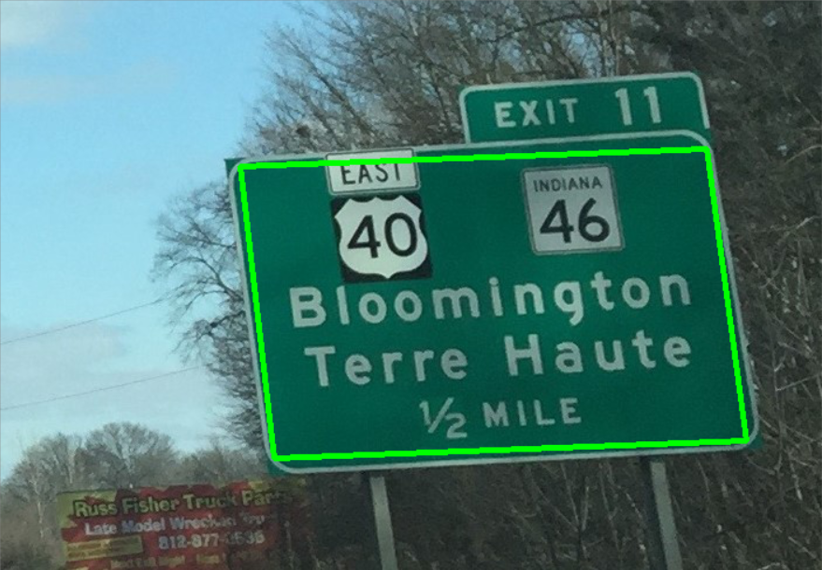 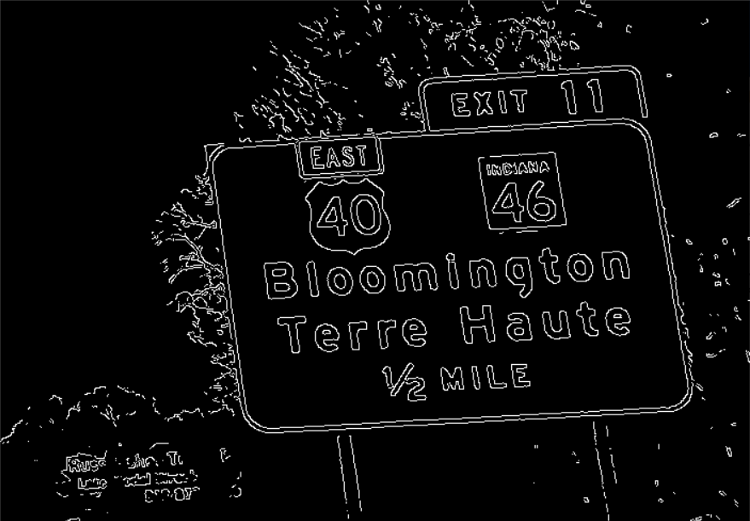

Auto crop:

